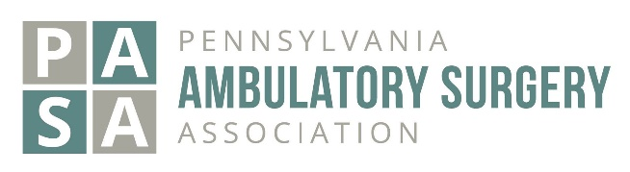
Pennsylvania Ambulatory Surgery Association
Annual Conference- November 8, 2021
Application and Contract for Commercial Exhibit Space

Please reserve space for our exhibit at the PASA Annual Conference, November 8, 2021. Full payment of the exhibit fee is enclosed. Our organization agrees to the terms of this contract.

ORGANIZATION____________________________________________________________________(Limit 30 characters)
ADDRESS__________________________________________________________________________________________
CITY_____________________________________________ STATE _____________________ ZIP ___________________
Description of Organization ___________________________________________________________________________
Organization Website Address _________________________________________________________________________
Indicate here if one electrical outlet is needed ___YES ____NO (more than one outlet is paid for by exhibitor)

CONTACT NAME ___________________________________ TITLE___________________________________________

TELEPHONE_______________________________________ EMAIL___________________________________________

I’m authorized by my organization for exhibit space at the PASA Annual Event as indicated above:

NAME ________________________________________ SIGNATURE__________________________________________

DATE___________________________________________ TITLE______________________________________________

If possible, please do not place our exhibit next to the following companies: __________________________________________________________________________________________________

2021 RATES:

PASA Vendor Members: $1,500.00 Non-Members: $1750.00 Registration deadline is October 1, 2021.
Registrations received after September 24, 2021 will not appear in any printed materials.

All exhibit booths include one 6' table, two company representatives, and two chairs. Representatives (2) are invited to share the complimentary breakfast and lunch provided at the event. Additional representatives/badges are $50.00 each. Full payment must accompany the contract; no space will be reserved without payment. Checks ONLY. No refunds.

Name:_____________________________________Email Address:_______________________ Phone #:_____________

Name:_____________________________________Email Address:_______________________ Phone #:_____________

Amount Enclosed ___________ Check Number_____________

All information requested must be provided.
NOTE: Contract and payment must be received by October 1, 2021
ADDRESS ALL COMMUNICATIONS TO:
PASA Administrative Secretary
PO Box 11516
Harrisburg, PA 17108-1516

